Project Design Phase-II Data Flow Diagram

|  |  |
| --- | --- |
| Date | 30 October 2022 |
| Team ID | PNT2022TMID19532 |
| Project Name | **Fertilizers Recommendation System for Disease Prediction** |
| Maximum Marks | 4 Marks |

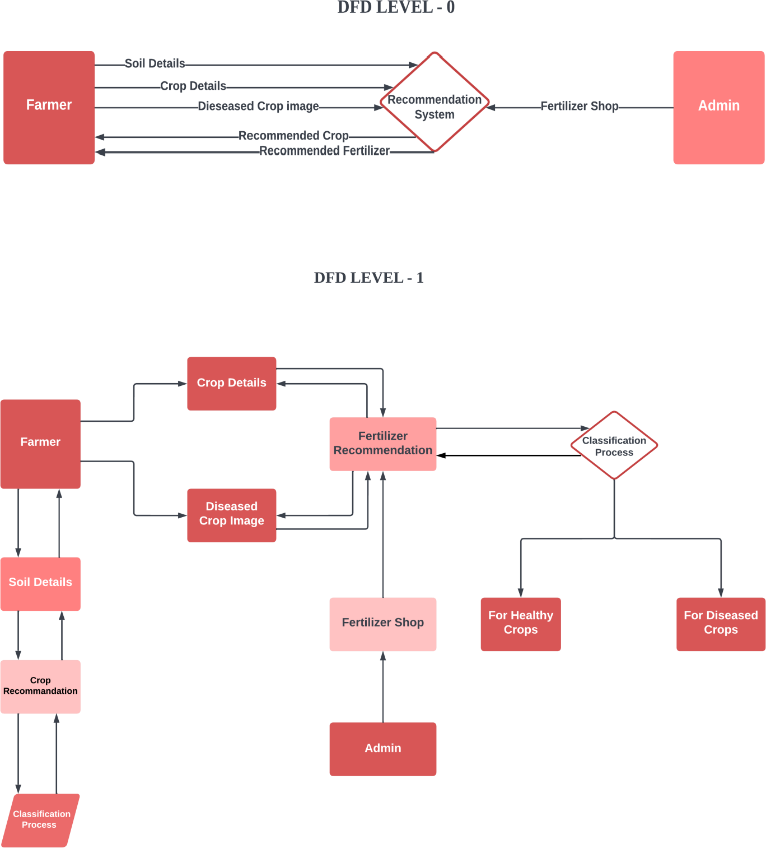

**User Stories**

Use the below template to list all the user stories for the product.

|  |  |  |  |  |  |  |
| --- | --- | --- | --- | --- | --- | --- |
| **User Type** | **Functional Requirement (Epic)** | **User Story Number** | **User Story / Task** | **Acceptance criteria** | **Priority** | **Release** |
| Customer (Mobile  user) | Registration | USN-1 | As a user, I can register for the application by entering my email, password, and confirming my  password. | I can access my account /  dashboard | High | Sprint-1 |
|  | Login | USN-2 | As a user, I can log into the application by entering email & password | I can login using my E-mail ID accounts or user  credentials | High | Sprint-1 |
|  | Dashboard | USN-3 | As a user, I can view the page of the application where i can upload my images and the  fertilizer should be recommended | I can access my account/ dashboard | High | Sprint-2 |
| Customer (Web  user) | Registration | USN-4 | As a user, I can login to web dashboard just Like website dashboard | I can register using my username and  password | High | Sprint-3 |
|  | Login | USN-5 | As a user, I can login to my web dashboard with the login credentials | I can login using my User  credentials | High | Sprint-3 |
|  | Dashboard | USN-6 | As a user, I can view the web application where I can upload my images and the  fertilizer should be recommended | I can access my account/ dashboard | High | Sprint-4 |
|  |  | USN-7 | As a user, the fertilizer recommended to me should be of higher accuracy | I can access my account/  dashboard | High | Sprint-4 |

|  |  |  |  |  |  |  |
| --- | --- | --- | --- | --- | --- | --- |
| **User Type** | **Functional Requirement**  **(Epic)** | **User Story Number** | **User Story / Task** | **Acceptance criteria** | **Priority** | **Release** |
| Administrator | Login | USN-8 | As a admin, I can login to the website using my login credentials | I can login to the website using my login credentials | High | Sprint-5 |
|  | Dashboard | USN-9 | As a admin, I can view the dashboard of the application | I can access my  dashboard | High | Sprint-5 |